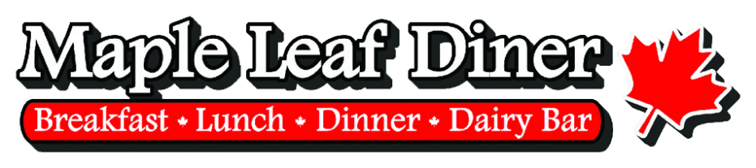
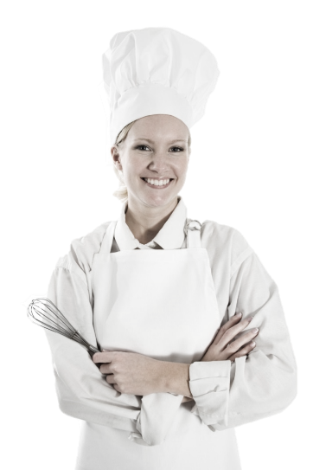

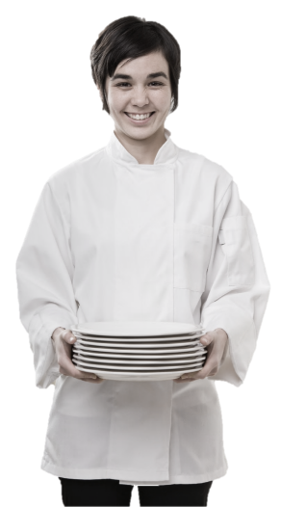
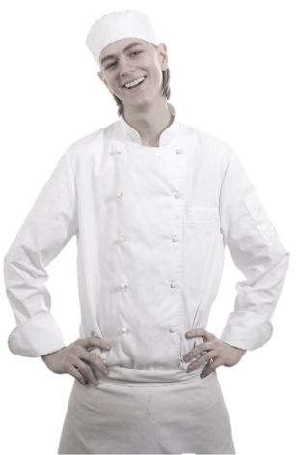

Line Cook
Training Manual

2019

Employment Policies and Procedures
Standard Operating Procedures
Table of Contents
Introduction
Line Cook Functions & Responsibilities
- General Job Guidelines And Responsibilities
- Line Cook Job Functions
Qualities of a Good Line Cook
Line Cook Closing Functions
Kitchen Sanitation & Cleanliness
- Major Causes of Food Borne Illness
- Dispos of Wast Properly
- Keep Instects and Animals Out
- Handle Ice and Tableware Properly
Food Handling & Storage
- Checking In Products
Recipes & Prep Sheets
- Recipes
- Daily Prep Sheets
Food Rotation
- FIFO Rotating System
- Food Dating Labels
- Storage
- Walk-in Cooler
- Storing Products In The Walk-In Cooler
- Freezer
- Stockroom (Dry Storage)
Cooling Products
- Cooling Down Large Batches/Quantities of Product
Kitchen Equipment & Terminology
Kitchen Tools
- Measuring & Portioning Tools (Cups, Spoons, Scoops, Ladles)
- Knives
- Recipe Books
- Lexans and Cambros
- Scales
- Sanitizing Solution & Spray Bottles
- Kitchen Counters & Sinks
- Can Opener
- Slicer
- Pots, Pans and Holding Containers
- Cutting Boards
- Utensils
Controlling Waste & Spoilage
Conclusion

Introduction
Congratulations on being selected to perform one of the most important, challenging and rewarding jobs at the Maple Leaf Diner!
As a Server, you will set the stage and have a direct impact on each guest's experience. You will determine whether each guest feels welcome, appreciated and well cared for.
We will provide you with the training you need to be successful. We take great pride in our quality food and friendly, responsive service. Our high standards can only be maintained through great people like you who share our values and desire to do the very best job possible for our guests every day.
As a server, it is essential that you maintain an energetic, friendly and caring attitude at all times. It is your responsibility to see that each guest is made to feel special and enjoys our fun atmosphere and great food and beverages.
The guidelines listed on the following pages have been established to help you in your effort to provide these qualities to our guests. Along with the hands-on training you will receive, this manual will provide answers to questions you may have regarding your tasks, responsibilities and operating procedures.
Once again, welcome to the Eh-Team!

Line Cook Functions & Responsibilities
Your role as a Line Cook is extremely important to our success. You will be trained extensively on how to perform your job. Your speed and efficiency are imperative to the smooth operation of the kitchen and the satisfaction of our guests. You will be provided with high quality products and the necessary tools and equipment to complete your daily duties.

General Job Guidelines And Responsibilities
Prepares a variety of meats, seafood, poultry, vegetables and other food items for cooking in broilers, ovens, grills, fryers and a variety of other kitchen equipment.
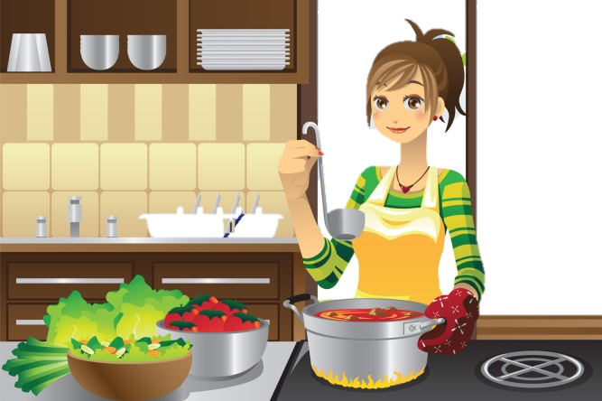
Assumes 100% responsibility for quality of products served.
Knows and complies consistently with our standard portion sizes, cooking methods, quality standards and kitchen rules, policies and procedures.
Stocks and maintains sufficient levels of food products at line stations to assure a smooth service period.
Portions food products prior to cooking according to standard portion sizes and recipe specifications.
Maintains a clean and sanitary work station area including tables, shelves, grills, broilers, fryers, pasta cookers, sauté burners, convection oven, flat top range and refrigeration equipment.
Prepares item for broiling, grilling, frying, sautéing or other cooking methods by portioning, battering, breading, seasoning and/or marinating.
Follows proper plate presentation and garnish set up for all dishes.
Handles, stores and rotates all products properly.
Assists in food prep assignments during off-peak periods as needed.
Closes the kitchen properly and follows the closing checklist for kitchen stations. Assists others in closing the kitchen.
Attends all scheduled employee meetings and brings suggestions for improvement.
Performs other related duties as assigned by the Kitchen Manager or manager-on-duty.

LINE COOK Job Functions
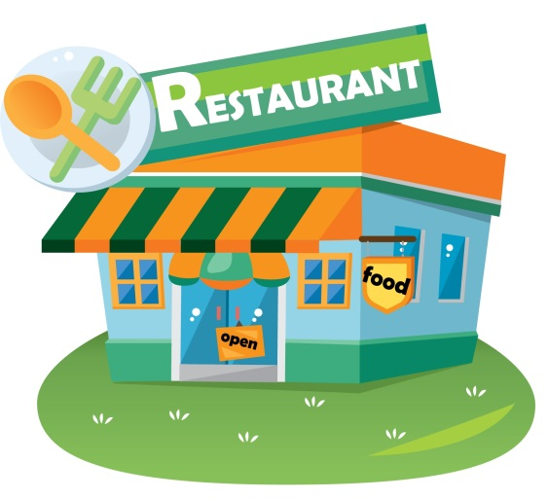
- Always arrive at least 5 minutes before your scheduled time.
- Always come to work with a clean uniform.
- Immediately ask the Kitchen Manager or manager-on-duty about menu specials and any other product, menu issues you should be aware of.
- Always observe and complete opening and closing checklists.
- Count your opening product inventory; place all products in its proper location.
- Clean and organize your area if necessary.
- Stock your food products and any equipment needed for station. Rotate products so that product from the prior shift is used first.
- Make certain you have all the product need to assure a smooth service period. Notify the Kitchen Manager or the manager-on-duty if you lack any products needed.
- Set and prepare station area and be ready for orders 15 minutes prior to service.
- Check thermostat settings of grills, ovens, fryers and other kitchen equipment and adjust if necessary.
- Double check your product levels to ensure that you won't have to leave your station during peak periods.
- Clean as you go - maintain a clean station and work area THROUGH OUT THE DAY.
- Follow recipe instructions EXACTLY as they are stated - ensure the quality, portion size, cooking time and consistency of every item that leaves your station.
- Be available to perform prep work during slow periods. Check in with the Kitchen Manager for a prep work assignment during slow periods.
- Be a team player - support and assist your fellow team members whenever possible in whatever functions are required.
- Ensure that all cooking equipment used is operating correctly and at the proper temperature.
- Report any broken or malfunctioning equipment to the (Kitchen Manager or manager-on-duty).
- ALWAYS follow safe food handling practices.
- Know and follow proper plate presentation and garnish set up for all dishes.
- Use our product labeling system to label, date, rotate and store all food products.
- Prepare only what is on the Daily Prep List.
- Do not work more than scheduled hours unless directed by the Kitchen Manager or manager-on-duty.
- Always check with Kitchen Manager or manager-on-duty prior to checking out.

Qualities of a Good Line Cook
Efficiency and speed | A good Line Cook must work quickly and efficiently so that our speed of service objectives are met while preparing food that meets our high standards of quality and plate presentation.
Organization | Since speed of execution is so important so is maintaining and organized work area. A good Line Cook keeps a sufficient level of product ready in the right storage areas. A good Line Cook has the right tools and equipment ready when needed.
Ability to perform well in a fact-paced work environment | A good Line Cook must be able to think quickly on his/her feet with multiple activities going on at once. A good Line Cook doesn't get flustered easily and even enjoys the challenge of an extra busy shift.
Focus on quality, pride in work | A Line Cook's work is placed directly in front of our guests. The type of job performed by our Line Cooks influences our guests' entire experience. Good Line Cooks takes great pride in serving great food and follows our high standards of quality and consistency on every product that leaves their station.
Always a Team Player | A good Line Cook is always aware of what's happening on the line and in the kitchen and is ready and willing to help others get the job done.

Line Cook Closing Functions
- Turn off ovens, grills, deep fryers, steam tables and stove burners.
- Take dirty pots, pans, utensils, etc. to dish room.
- Place leftovers in appropriate containers and store in designated storage areas. Allow all hot items to cool before covering.
- Cleaning and Organization:
  - Grills (over and under).
  - Clean, rotate and refill grease in deep fryers. Replace grease before food quality is affected. Check with Kitchen Manager to be sure.
  - Clean area around fryers.
  - Clean burner stove.
  - Clean under steam table and refill with water if needed.
  - Clean in and around microwave.
  - Clean and restock seasoning containers.
  - Clean toasters and trays underneath.
  - Clean and organize all prep areas, walk-in cooler and freezer.
  - Wipe in and around oven.
  - Wipe down all counters and shelves in the kitchen.
  - Sweep and mop floor with cleaning solution. Rinse the hose and hot water.
- Restocking responsibilities:
  - Change out and restock sandwich and patty condiments.
  - Restock china.
  - Restock drawers and refrigerator.

Check with Kitchen Manager before preparing to leave.

Kitchen Sanitation & Cleanliness
Throughout your training, you will receive information concerning proper cleanliness standards, proper use of chemical cleaning, and disinfectant products. It is always our #1 objective to operate our restaurant at the highest level of sanitation and cleanliness for the benefit of our guests and employees.

Dispose Of Waste Properly
- Take garbage out frequently.
- Keep garbage areas clean and sealed.
- Clean and sanitize garbage cans regularly.
- Store soiled linen in a laundry bag or non-absorbing container.

Keep Insects And Animals Out By
- Keeping doors closed.
- Taking garbage out frequently and keeping garbage areas clean.
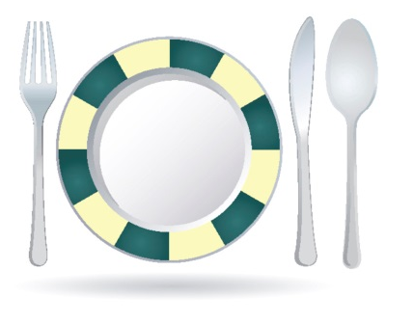
- Report any holes where an animal can enter.
- Do not provide a free meal for any animals.

Handle Ice And Tableware Properly
- Use clean scoops or tongs to pick up ice, do not use hands or glass.
- Store scoops or tongs in a clean container, not in the ice.
- Do not store any food or beverage in the ice.
- Avoid touching food contact surface with dishes, utensils, etc.

Kitchen Cleanliness
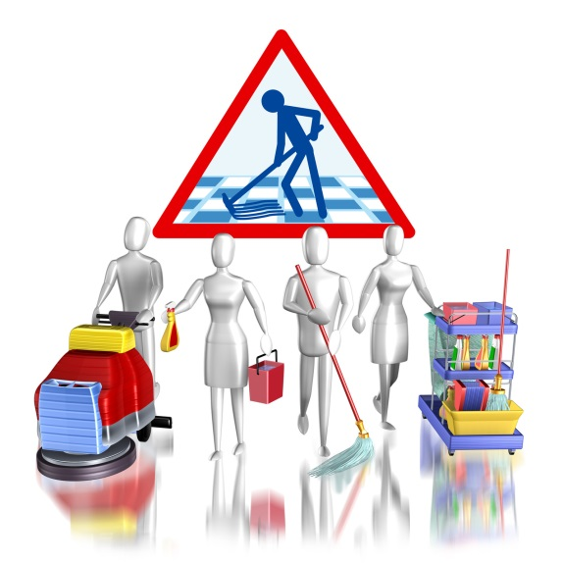
- Sanitation solution (spray) should be used on all food contact surfaces after they have been cleaned or when switching from one food product to another.
- Sanitation solution should be always be accessible in the kitchen. Frequently rinse all cloths used to wipe counters in this solution.
- Store all cleaning products, insecticides, poisons and chemicals AWAY FROM FOOD.
- Wash mops like brushes – in hot water and hang to dry. Rinse mop buckets immediately and store after use.
- All employees should help maintain clean and organized walk-in, freezer, dry storage and other storage areas.
- All pots and pans, food storage containers and trays should be inverted after cleaning.
- Maintain and clean kitchen equipment on a regular basis.
- Clean microwave oven door seals and cavities regularly.

Sanitation Solution and Spray
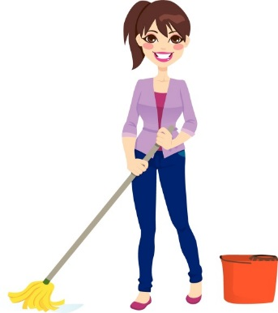
- Our sanitation solution is safe to use on all equipment and surfaces that come into contact with food products. It requires no rinsing or wipe down after use. It evaporates very quickly because it has a high bleach content.
- Use our sanitation solution spray frequently and generously.
- Plastic spray bottles should be used and accessible anywhere in the kitchen.
- After cleaning equipment and counters, spray generous amounts of sanitation solution.
- Clean towels should be available for use with sanitation solution.

Food Handling & Storage

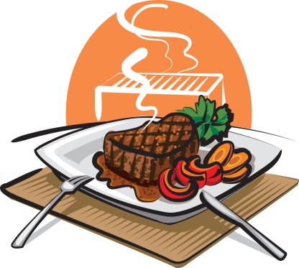
Checking in products
Use a thermometer to measure temperature of products. Reject products if the temperature is above the following amounts.

Product Temperature
Fresh meat | 41° F or lower
Fresh poultry | 41° F or lower
Fresh fish | 41° F or lower
Fresh lobster, shrimp and shellfish | 45° F or lower
Milk & milk products | 41° F or lower
Ice cream | 6° to 10° F
Liquid eggs | 41° F or lower
Reject cans that are dented, leak, contain rust or are missing labels
Reject produce that has any signs of mold, spoilage or insect damage

Avoid Cross Contamination From One Food Item To Another
Keep separate cutting boards for raw and cooked foods.
Never mix leftovers with fresh food.
Store fresh raw meats, poultry, and fish on lowest racks.
Sanitize thermometers after each use.
When thawing raw foods in the refrigerator, place them on the lowest shelf.

Store Foods And Equipment Properly
Cover, label, and date foods in storage.
Do not store food in open containers.
Empty all canned products and store in proper containers.
Always place raw food products below cooked or ready-to-eat products.
Store new foods behind old ones so older products get used first.
Always place food in clean containers or wrappers.
Keep storage containers off the floor and away from the wall.
Check temperatures of refrigerators and freezers daily.

Product Temperature
Refrigerator air temperature | Between 35 - 38° F
Freezer air temperature | Between -10 - 0° F
Defrost freezers as necessary. Frost build up causes freezers to warm up.
Throw away any food that gets beyond its use-by or expiration date.
Dry goods and storage areas should be cool and dry.
Do not store food or equipment under exposed server lines.
Keep storage areas clean.
Store all equipment so that dust cannot settle on it.
Store chemicals and pesticides separately from food.

Handle Ice And Tableware Properly
Use clean scoops or tongs to pick up ice, do not use hands or glass.
Store scoops or tongs in a clean container, not in the ice.
Do not store any food or beverage in the ice.
Avoid touching food contact surface with dishes, utensils, etc.

Chemical Handling & Storage
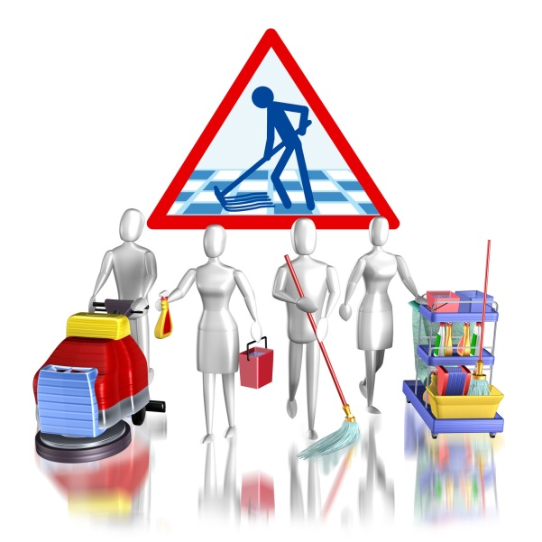
Always wash your hands thoroughly and change your uniform after handling chemicals
Store away from food preparation, handling and storage areas.
Keep chemicals in their original containers or another clearly labeled, sturdy container.
Never allow chemical to come in contact with food. Immediately throw away any food that comes in contact with chemicals of any kind.
Clean up chemical spills promptly, then wash your hands and change your uniform.
Never place food in chemical containers or place chemicals in a food container.

Dispose Of Waste Properly
Take garbage out frequently.
Keep garbage areas clean and sealed.
Clean and sanitize garbage cans regularly.
Store soiled linen in a laundry bag or non-absorbing container.

Keep Insects And Animals Out By . . .
Keeping doors closed.
Taking garbage out frequently and keeping garbage areas clean.
Report any holes where an animal can enter.
Do not provide a free meal for any animals.

Recipes & Prep Sheets

Recipes
It is absolutely critical that all instructions and measurements on all recipes be followed exactly! Never assume you've memorized the preparations of any products. Always use the recipe sheet when preparing any products. These steps MUST be followed so that we serve food with the same great taste, texture and color to every guest, consistently, time after time.
Here is an example of a recipe:
When preparing recipes you need to know the types of units used to measure ingredient portions. Notice in the recipe about there is weight, volume and quantity unit type.
Weight units are pounds and ounces and are measured using a scale.
Volume units are cups, tablespoons, teaspoons, etc. and are measured using cups and spoons.
Quantity (each) is the number of items as in the number of bags, cans, boxes, patties, etc. that are in the recipe. Quantity units are referred to as "EA" in the Recipe Book.
When preparing recipes ALWAYS . . .

. . . read the entire recipe and gather all the utensils and ingredients you'll need.
. . . double check to be sure that the batch size you prepare is the amount called for on the Prep Sheet.

Daily Prep Sheets
The Daily Prep Sheets are a major tool in controlling our food cost and ensuring we always have a sufficient quantity of fresh quality food. The Kitchen Manager will fill out the Daily Prep Sheet each morning. Use your Prep Sheets! Preparing too much is costly. Not preparing enough food creates unnecessary fire drills and service problems.

How To Read The Daily Prep Sheet
On Hand | The amount of usable product left over from the previous day. The Kitchen Manager or manager-on-duty determines this by taking a physical count and inspection of products on hand.
Par Level | Par levels are determined based upon the average usage of products on peak (Thursday - Saturday) and non-peak days (Sunday - Wednesday) of the week. The Kitchen Manager and Managers are responsible for updating par levels as product usage and sales fluctuate.
Make | The amount to prep that day to build up to the Par Level.
Name | Name of the person assigned to prepare the product.
Directions:
When work has begun on a product highlight the Product Name with a yellow marker.
Once the product has been prepared highlight the entire line.

Food Rotation
All food products used in our restaurant should be dated when they are received and put into storage and dated again when they are prepared into secondary products. Products are always rotated using the first-in, first-out (FIFO) method.

FIFO Rotating System
Always refer to the "received on" or "prepared on" date and use the oldest products first as long as the "use by" date has not passed. If the "use by" date has been passed, notify the Kitchen Manager and discard the all the product in the container. FIFO means to always stock older product on top or in front of the new product so the older product is most accessible and is used first.

Food Dating Labels
Dating labels are pre-printed, colored stickers used to assist employees with the properly rotating food. Every product that is prepared receives a food label.
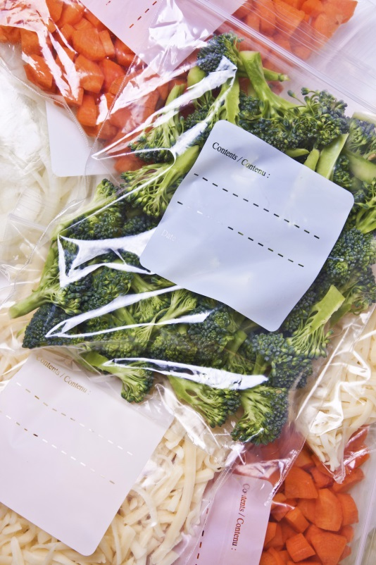
What to write on the label:
Product name or abbreviation
Date
AM/PM (all items prepared after 2:00 PM)
Initials

Storage
When deliveries are received products need to be unloaded and placed in storage in the following order
- Walk-in cooler
- Freezer
- Stockroom (dry storage)
Chilled products need to go directly to the walk-in cooler first as they are the most perishable items.
Remember, the FIFO rotation method, discussed above - always stock new product on the bottom or in back of older product so that the older product is most accessible and is used first. Always use a food label or a permanent black marking pen to record the date received.
Only store food products in designated food storage areas.

Walk-in Cooler
The temperature in the walk-in cooler should be maintained at 36°-38°F at all times. Store food at this temperature keeps bacteria organisms from growing in the food and prevents food from freezing.
Be aware of the temperature in the walk-in cooler and other refrigerators. Notify the manager immediately if any refrigerated storage area reaches a temperature of 40o F.

Storing products in the walk-in cooler
Organizing the walk-in cooler the crucial. Place frequent use items near the door so they are easily accessible.
Always place raw products below cooked or ready-to-eat products
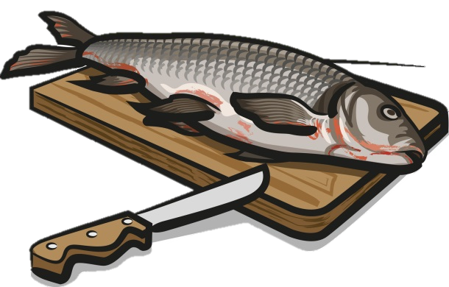
Fish and shellfish products are highly perishable. Store these items away from the door in the coldest areas of the walk-in.
Eggs and dairy products can absorb odors and flavors from other foods. These products should be stored in tightly sealed containers and away from foods with strong odors like fish, certain cheeses, cabbage and onions.

Freezer
The temperature in the freezer should be maintained at 0o to -10oF.
All items in the freezer should be at least 6 inches off the floor and the containers must stay sealed or the product will become freezer-burned.
Once an item has thawed, even partially, it should NOT BE REFROZEN. Only removed products from the freezer that will be used promptly.
Do not pack boxes and container in the freezer too tightly together. Leave enough space so that cold air can circulate freely. Packages packed to tightly in the freezer can cause the contents to defrost.

Stockroom (dry storage)
Keep the stockroom organized and clean of debris at all times.
Keep all food products at least 6 inches of the floor.
Keep all chemicals on a bottom shelf separate from all other products.
Place heavier containers on the lower shelves.

Cooling Products
After each evening shift there are hot products that must be properly cooled down and stored. Hot products must be covered and vented to prevent spoilage. Without proper venting, steam will continue to heat the product and it will take approximately twice as long to cool down. This causes the product to stay in the temperature danger zone (41-135 degrees F) too long and dramatically increases the chances of bacteria growth, contamination and spoilage.
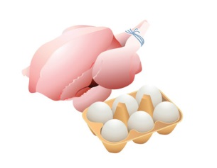
Containers that are covered with foil can be vented by carefully placing a hole about the size of your thumb in the foil on each side of the pan. BE SURE that no foil comes in contact with the product. This can cause product to become discolored and possibly spoil. Products that are stored with lids can be vented by placing the lid in a crooked fashion across the top of the container.
In addition to venting hot products, also make sure there is enough cool air surrounding each container. There should be at least 2 inches of space between each container to allow cold, circulating air to surround all sides of the container and cool the product down in the shortest amount of time possible.

Cooling Down Large Batches/Quantities of Product
Large quantities of certain products such as soups, baked beans and chili will take a long period of time to cool down. Because of the density of these products, they will remain in their danger zone too long, which increases the chances of spoilage, contamination and a decreased shelf life.
Additional steps must be taken to cool these products at a faster rate by using an ice bath. Fill a sink with ice and place the product in the largest and shallowest metal pan available. Put the pan on the ice for around 45 minutes while stirring occasionally. After the 45 minute period, remove from the ice, transfer to the proper storage container, then label, date and rotate and place in the walk-in.
Remember all products must be cooled down before they are placed in the walk-in!

Kitchen Equipment & Terminology
Term | Description
Blanch | To immerse in boiling water or oil to loosen skins, partially cook and heighten color and flavor. (Example: our home-made fries)
Colander | A large bowl-looking utensil with many holes, used for draining, straining and washing food.
Chop | To cut into small pieces but much larger pieces than in mincing or dicing.
China Cap Strainer | Metal strainer with pointed, perforated tip.
Dice | To cut into small pieces, usually 1/8" x 1/8" or 1/4" x 1/4".
"86" | Term used when kitchen is out of a particular item or when customer has requested that an item be withheld from an order (example: dinner salad but "86" the tomatoes).
Ice Bath | Steps used to cool down a hot product quickly before refrigerating.
Lexan | Durable, clear plastic container used for storing food.
Measuring Cups | Usually a set of 4 different sized cups used for measuring liquids and some solids. Cups have indentations for smaller quantities.
Pot Sinks | Deep sinks used for washing dirty pots and pans.
Prep Sinks | Deep basin used for food preparation only. Pots and pans are not to be washed in these sinks. Screens are placed over the drain openings and must not be removed.
Scales | Equipment used for weighing food.
Sheet Pans | Large pans used for food storage, cooking and baking
Shelf life | Term used to describe the length of time a product can be stored without the loss of quality.
Simmer | To heat liquid until just as it begins to steam, but does not come to a boil.
Slicer | Equipment used to slice cheese, meat and fruit. Useful in creating products of consistent appearance, size and weight.
Spatula | A rubber utensil used to scoop or scrape food from containers or cans. Also called a "rubber scrapper." Can also be a flat metal utensil used to flip burgers, pancakes or any other grilled product.
Strainers | Metal screens with long handles and hooks used to strain products.
Whip | To beat a product into a smooth consistency, usually with a wire whip or electric blender.
Measuring Spoons | Used to measure ingredients and spices. Consists of tablespoon, teaspoon, ½ teaspoon and ¼ teaspoon.
Ladles | Stainless steel "bowls" of various ounce sizes attached to a long stainless handle. Ladles come in many sizes.
Perforated Spoons | Long-handled stainless spoons with holes in the bowl shaped end. Used to scoop and portion food without getting the juice.
Slotted Spoons | Long handled stainless spoon without holes or slots. Used as a portioning tool.

Kitchen Tools

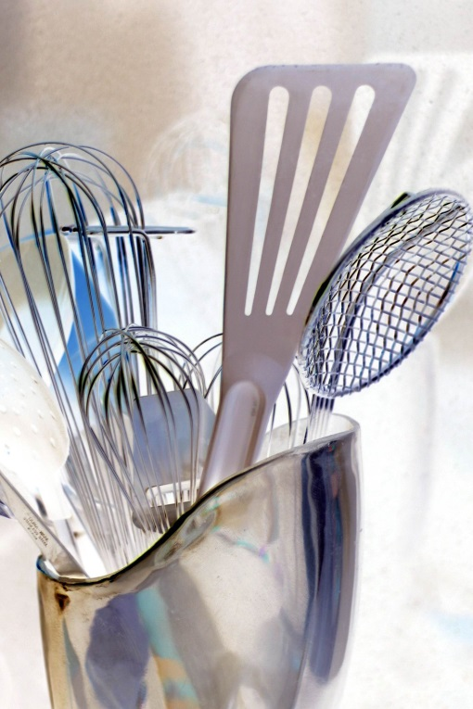
Measuring & Portioning Tools (cups, spoons, scoops, ladles)
Always use the "correct" measuring/portioning tools consistently.
Always use level measurements.

Knives
Sharpen regularly, usually daily.
Clean and sanitize after each use.
Hand wash only (never put through dish machine).
Hang knives with blades down.

Recipe Books
Don't think you can memorize. Always use the Recipe Book.
Measure precisely, don't approximate.

Scales
Clean and sanitize after use
Use consistently
Calibrate regularly using a separate weight
Always carry by base, never by platform

Sanitizing Solution & Spray Bottles
Make available throughout kitchen in prep and line areas
Use regularly on knives, utensils, counters, cutting boards and equipment

Kitchen Counters & Sinks
Clean and sanitize regularly
Use for food preparation only
Do not use chemicals

Can Opener
Clean after each use
Located on prep table

Slicer
Know proper settings for each product
Never leave unattended
Always keep hands away from blade
Keep clean, sanitize after every use

Pots, Pans and Holding Containers
Store in proper locations, always upside down
Send through dishwasher

Cutting Boards
Wash by hand only
Clean and sanitize after each use
When using, keep a damp towel underneath to keep from sliding

Utensils
Serving spoons - used for stirring or serving
Ladles - used for accurately portioning products
Tongs - long or short handles
Perforated or slotted spoons - used for stirring or serving
Whips - used to stir, whip or mix products

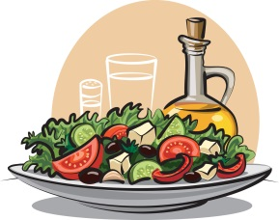
Controlling Waste & Spoilage
In order for our restaurant to be successful, we not only have to serve great food and deliver outstanding service but we also have to control our costs. Controlling costs is everyone's business and responsibility.
Here are some of the ways you can help to control costs and reduce waste:

Rotation | Improper rotation is a double-edged sword. When product don't get dated or aren't rotated properly they are more often subject to spoilage. Even worse, improper rotation increases the risk that we might serve something less than fresh, high quality food, which could mean a dissatisfied (or even sick) guest. Always label, date and rotate!
Portioning & Measuring | Always use the correct portioning and measuring tools (scoops, ladles, spoons, cups, scales). Don't over or under portion. Consistency is the name of the game!
Maximize Product Yields | Always get as much as possible from all produce, cans and jars. Be careful not to send good, usable product to the trash can.
Product Storage | Always follow proper cool down procedures. Not cooling down products properly before placing them in the walk-in can cause spoilage. Cover products properly to keep them fresh and good tasting.
Scraping | Always use a rubber scraper (spatula) on cans, jars, containers, etc., to get it ALL! This is a low margin business and those small amounts of product worth pennies, nickels and dimes add up to big dollars over time.

Conclusion
There is a lot of information contained in this manual! Believe it or not, however, there is even more information that is not.
We have given you the basics, as we view them, and how we would like them to be conducted.
We want you to use the service tips in the manual, along with your common sense, and above all, YOUR individuality, to help create an atmosphere that will encourage good times for our customers, and yourself. If this happens, you will be ensuring the success of not only the restaurant, but also yourself.
GOOD LUCK!!!

