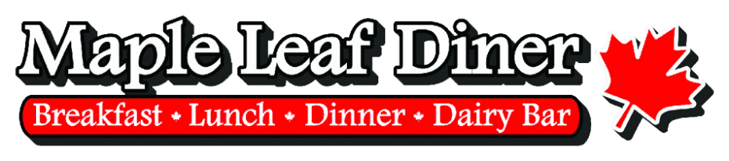
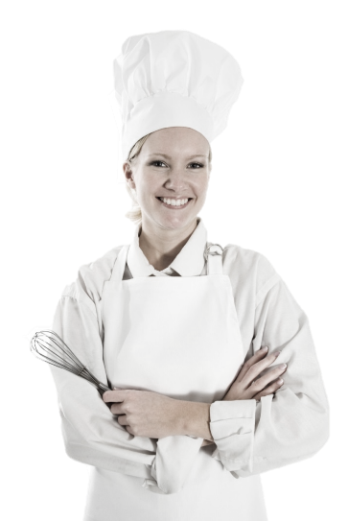

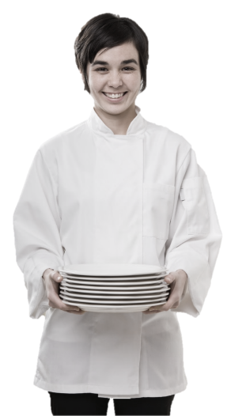
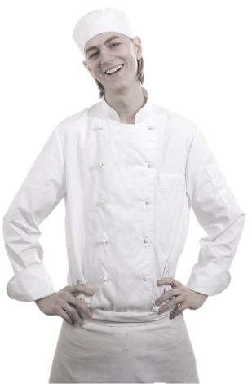

Prep Cook
Training Manual

2019

Employment Policies and Procedures
Standard Operating Procedures
Table of Contents
Introduction
Prep Cook Functions & Responsibilities
- General Job Guidelines And Responsibilities
- Prep COOK Job Functions
Qualities of a Good Prep Cook
Kitchen Closing Checklist
- Prep Area
- Freezer
- Walk-in Cooler
Kitchen Sanitation & Cleanliness
- Major Causes of Food Borne Illness
Kitchen Cleanliness
- Sanitation Solution and Spray
Food Handling & Storage
- Checking in products
Temperatures for Food Safeness
Kitchen Equipment & Terminology
Kitchen Tools
- Measuring & Portioning Tools (cups, spoons, scoops, ladles)
- Knives
- Recipe Books
- Lexans and Cambros
- Scales
- Sanitizing Solution & Spray Bottles
- Kitchen Counters & Sinks
- Can Opener
- Slicer
- Pots, Pans and Holding Containers
- Cutting Boards
- Utensils
Cooling & Venting Products
Controlling Waste & Spoilage
Conclusion

Introduction
Congratulations on being selected to perform one of the most important, challenging and rewarding jobs at the Maple Leaf Diner!
As a Server, you will set the stage and have a direct impact on each guest's experience. You will determine whether each guest feels welcome, appreciated and well cared for.
We will provide you with the training you need to be successful. We take great pride in our quality food and friendly, responsive service. Our high standards can only be maintained through great people like you who share our values and desire to do the very best job possible for our guests every day.
As a server, it is essential that you maintain an energetic, friendly and caring attitude at all times. It is your responsibility to see that each guest is made to feel special and enjoys our fun atmosphere and great food and beverages.
The guidelines listed on the following pages have been established to help you in your effort to provide these qualities to our guests. Along with the hands-on training you will receive, this manual will provide answers to questions you may have regarding your tasks, responsibilities and operating procedures.
Once again, welcome to the Eh-Team!

Prep Cook Functions & Responsibilities
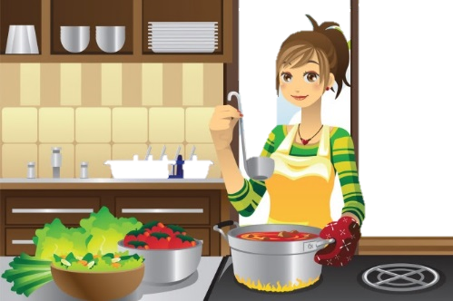
Your role as a Prep Cook is extremely important to our success. You will be trained extensively on how to perform your job. Your speed and efficiency are imperative to the smooth operation of the kitchen and the satisfaction of our guests.
You will be provided with high quality products and the necessary tools and equipment to complete your daily duties.

General Job Guidelines And Responsibilities
Always arrive at least 5 minutes before your scheduled time.
Always come to work with a clean uniform.
Check your duties for the day by reviewing prep list, cooler pull list, etc.
Get organized and plan your day before beginning your work.
Sanitize and clean your work area.
Clean as you go - maintain a clean station and work area THROUGH OUT THE DAY.
Follow the recipes - ensure the quality and consistency of every batch recipe that goes from our prep kitchen to the proper workstation on the line.
Be a team player - support and assist your fellow team members whenever possible.
Ensure that all slicers, scales, refrigeration and cooking equipment are operating correctly and at the proper temperature.
Report any broken or malfunctioning equipment to the (chef, kitchen manager or manager-on-duty).
ALWAYS follow safe food handling practices.
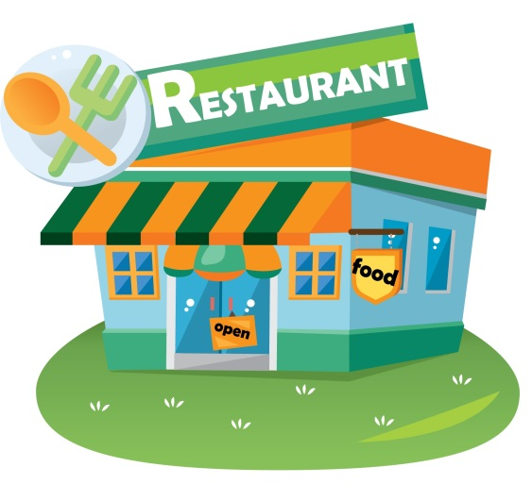
Maintain your daily and weekly sanitation and maintenance schedules.
Never store raw poultry, meat or fish products above cooked or ready-to-eat products.
Maintain a safe, clean and organized workstation and walk way in the prep areas.
Use our product labeling system to label, date, rotate and store all food products.
Prepare only what is on the Daily Prep List.
Clean all equipment and workstations immediately after use.
Do not work more than scheduled hours unless directed by manager-on-duty.
Always check with Manager prior to checking out.

Prep COOK Job Functions
- Clock in.
- Get apron and towel.
- Scrub hands.
- Sanitize work area with sanitation-solution.
- Get organized - assemble your tools including cutting board, scale, knives, pans, measuring tools, etc.
- Review Prep List - prioritize, determine what products are needed to open.
- Begin working on Prep List items.
- Don't work on too many items at one time. Limit yourself to 2 products at once.
- During lunch, provide backup for anything needed on the line.
- Maintain a clean work area - clean as you go.
- Do not allow any products to remain in the danger zone (41-135 degrees F) for more than one hour before being prepared.
- When all Prep List items are complete, have kitchen manager review and check out.
- Cleanup -
Clean all utensils
Scrub and sanitize sinks and countertops
Clean walls around work areas
Put back all utensils, equipment and measuring tools in their storage places.
Sanitize all counters, sinks and equipment
Clean and organize coolers - all products should be in their proper shelf location and in proper covered container.
Sweep and clean walk-in floor.
Sweep and clean dry storage area.
Dispose of apron, towels and any soiled linen in the appropriate dirty laundry bins.

Qualities of a Good Prep Cook
Efficiency And Speed | A good Prep Cook must work quickly and efficiently to provide the quantity of products needed to keep up with our volume of business.
Organization And Focus | A good Prep Cook stays focused on one or two tasks at a time and completes those tasks before moving on to something else. The workstation is not cluttered, when one task is finished, utensils, tools and equipment are cleaned and put away if not needed.
Attention To Cleanliness And Sanitation | Much of a Prep Cook's job is involved with maintaining standards of cleanliness in the kitchen. A good Prep Cook must be aware of our cleaning and sanitation standards and must maintain them consistently.
Always a Team Player | A good Prep Cook is always aware of what's going on in the kitchen and is ready and willing to help others get the job done.
Efficiency And Speed | A good Prep Cook must work quickly and efficiently to provide the quantity of products needed to keep up with our volume of business.

Kitchen Closing Checklist

Prep Area
Clean and organize under prep tables
Clean, wipe and dry sinks
Clean, wipe and dry walls
Clean and sanitize countertops
Empty and reline all trash cans
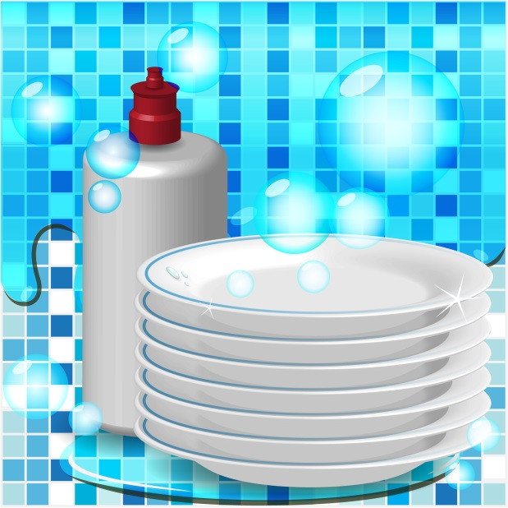
Clean and organize dry storage area
Sweep and mop prep area floor

Freezer
Verify that temperature is between 0 and 10 degrees F.
Clear the floor
Organize shelves
Rotate products, oldest products in front, discard products that have exceeded their pull date
Sweep and clean floor

Walk-in Cooler
Verify that temperature is between 36 and 40 degrees F.
Ensure that all products are covered and in the proper containers
Organize shelves, ensure that all containers are (Daydot) labeled
Rotate products, oldest products in front, discard products that have exceeded their pull date
Clean and wipe racks from top to bottom
Sweep, scrub and dry mop floor

Kitchen Sanitation & Cleanliness
Throughout your training, you will receive information concerning proper cleanliness standards, proper use of chemical cleaning, and disinfectant products. It is always our #1 objective to operate our restaurant at the highest level of sanitation and cleanliness for the benefit of our guests and employees.

Dispose Of Waste Properly
- Take garbage out frequently.
- Keep garbage areas clean and sealed.
- Clean and sanitize garbage cans regularly.
- Store soiled linen in a laundry bag or non-absorbing container.

Keep Insects And Animals Out By
- Keeping doors closed.
- Taking garbage out frequently and keeping garbage areas clean.
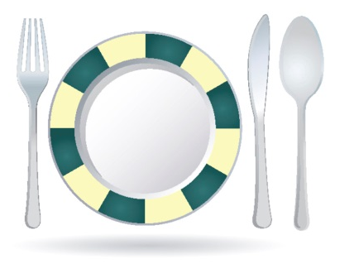
- Report any holes where an animal can enter.
- Do not provide a free meal for any animals.

Handle Ice And Tableware Properly
- Use clean scoops or tongs to pick up ice, do not use hands or glass.
- Store scoops or tongs in a clean container, not in the ice.
- Do not store any food or beverage in the ice.
- Avoid touching food contact surface with dishes, utensils, etc.

Kitchen Cleanliness
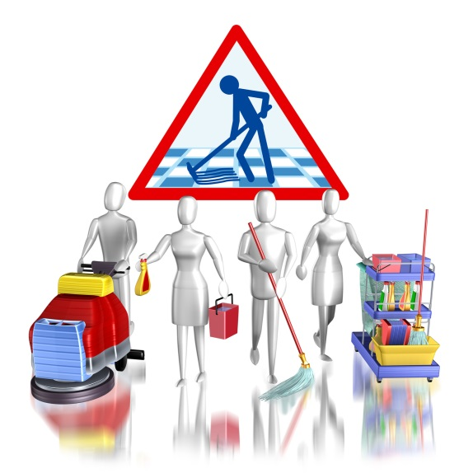
- Sanitation solution (spray) should be used on all food contact surfaces after they have been cleaned or when switching from one food product to another.
- Sanitation solution should be always be accessible in the kitchen. Frequently rinse all cloths used to wipe counters in this solution.
- Store all cleaning products, insecticides, poisons and chemicals AWAY FROM FOOD.
- Wash mops like brushes – in hot water and hang to dry. Rinse mop buckets immediately and store after use.
- All employees should help maintain clean and organized walk-in, freezer, dry storage and other storage areas.
- All pots and pans, food storage containers and trays should be inverted after cleaning.
- Maintain and clean kitchen equipment on a regular basis.
- Clean microwave oven door seals and cavities regularly.

Sanitation Solution and Spray
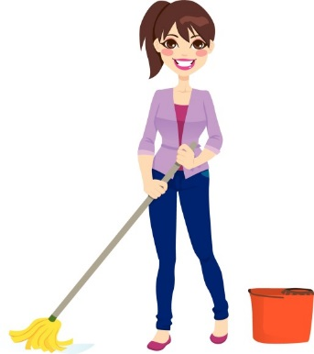
- Our sanitation solution is safe to use on all equipment and surfaces that come into contact with food products. It requires no rinsing or wipe down after use. It evaporates very quickly because it has a high bleach content.
- Use our sanitation solution spray frequently and generously.
- Plastic spray bottles should be used and accessible anywhere in the kitchen.
- After cleaning equipment and counters, spray generous amounts of sanitation solution.
- Clean towels should be available for use with sanitation solution.

Food Handling & Storage

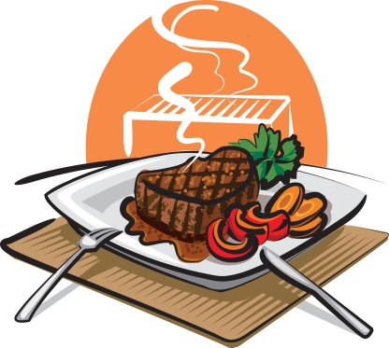
Checking in products
Use thermometer to measure temperature of products. Reject products if the temperature is above the following amounts.

Product Temperature
Fresh meat | 41° F or lower
Fresh poultry | 41° F or lower
Fresh fish | 41° F or lower
Fresh lobster, shrimp and shellfish | 45° F or lower
Milk & milk products | 41° F or lower
Ice cream | 6° to 10° F
Liquid eggs | 41° F or lower
Reject cans that are dented, leak, contain rust or are missing labels
Reject produce that has any signs of mold, spoilage or insect damage

Avoid Cross Contamination From One Food Item To Another
Keep separate cutting boards for raw and cooked foods.
Never mix leftovers with fresh food.
Store fresh raw meats, poultry, and fish on lowest racks.
Sanitize thermometers after each use.
When thawing raw foods in the refrigerator, place them on the lowest shelf.

Store Foods And Equipment Properly
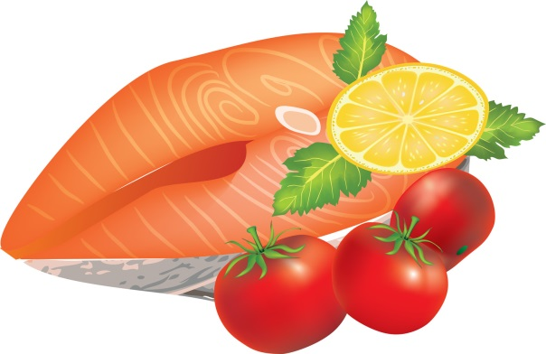
Cover, label, and date foods in storage.
Do not store food in open containers.
Empty all canned products and store in proper containers.
Always place raw food products below cooked or ready-to-eat products.
Store new foods behind old ones so older products get used first.
Always place food in clean containers or wrappers.
Keep storage containers off the floor and away from the wall.
Check temperatures of refrigerators and freezers daily.

Product Temperature
Refrigerator air temperature | Between 35 - 38° F
Freezer air temperature | Between -10 - 0° F
Defrost freezers as necessary. Frost build up causes freezers to warm up.
Throw away any food that gets beyond its use-by or expiration date.
Dry goods and storage areas should be cool and dry.
Do not store food or equipment under exposed server lines.
Keep storage areas clean.
Store all equipment so that dust cannot settle on it.
Store chemicals and pesticides separately from food.

Handle Ice And Tableware Properly
Use clean scoops or tongs to pick up ice, do not use hands or glass.
Store scoops or tongs in a clean container, not in the ice.
Do not store any food or beverage in the ice.
Avoid touching food contact surface with dishes, utensils, etc.

Chemical Handling & Storage
Always wash your hands thoroughly and change your uniform after handling chemicals
Store away from food preparation, handling and storage areas.
Keep chemicals in their original containers or another clearly labeled, sturdy container.
Never allow chemical to come in contact with food. Immediately throw away any food that comes in contact with chemicals of any kind.
Clean up chemical spills promptly, then wash your hands and change your uniform.
Never place food in chemical containers or place chemicals in a food container.

Dispose Of Waste Properly
Take garbage out frequently.
Keep garbage areas clean and sealed.
Clean and sanitize garbage cans regularly.
Store soiled linen in a laundry bag or non-absorbing container.

Keep Insects And Animals Out By . . .
Keeping doors closed.
Taking garbage out frequently and keeping garbage areas clean.
Report any holes where an animal can enter.
Do not provide a free meal for any animals.

Kitchen Equipment & Terminology
Term | Description
Blanch | To immerse in boiling water or oil to loosen skins, partially cook and heighten color and flavor. (Example: our home-made fries)
Colander | A large bowl-looking utensil with many holes, used for draining, straining and washing food.
Chop | To cut into small pieces but much larger pieces than in mincing or dicing.
China Cap Strainer | Metal strainer with pointed, perforated tip.
Dice | To cut into small pieces, usually 1/8" x 1/8" or 1/4" x 1/4".
"86" | Term used when kitchen is out of a particular item or when customer has requested that an item be withheld from an order (example: dinner salad but "86" the tomatoes).
Ice Bath | Steps used to cool down a hot product quickly before refrigerating.
Lexan | Durable, clear plastic container used for storing food.
Measuring Cups | Usually a set of 4 different sized cups used for measuring liquids and some solids. Cups have indentations for smaller quantities.
Pot Sinks | Deep sinks used for washing dirty pots and pans.
Prep Sinks | Deep basin used for food preparation only. Pots and pans are not to be washed in these sinks. Screens are placed over the drain openings and must not be removed.
Scales | Equipment used for weighing food.
Sheet Pans | Large pans used for food storage, cooking and baking
Shelf life | Term used to describe the length of time a product can be stored without the loss of quality.
Simmer | To heat liquid until just as it begins to steam, but does not come to a boil.
Slicer | Equipment used to slice cheese, meat and fruit. Useful in creating products of consistent appearance, size and weight.
Spatula | A rubber utensil used to scoop or scrape food from containers or cans. Also called a "rubber scrapper." Can also be a flat metal utensil used to flip burgers, pancakes or any other grilled product.
Strainers | Metal screens with long handles and hooks used to strain products.
Whip | To beat a product into a smooth consistency, usually with a wire whip or electric blender.
Measuring Spoons | Used to measure ingredients and spices. Consists of tablespoon, teaspoon, ½ teaspoon and ¼ teaspoon.
Ladles | Stainless steel "bowls" of various ounce sizes attached to a long stainless handle. Ladles come in many sizes.
Perforated Spoons | Long-handled stainless spoons with holes in the bowl shaped end. Used to scoop and portion food without getting the juice.
Slotted Spoons | Long handled stainless spoon without holes or slots. Used as a portioning tool.

Kitchen Tools

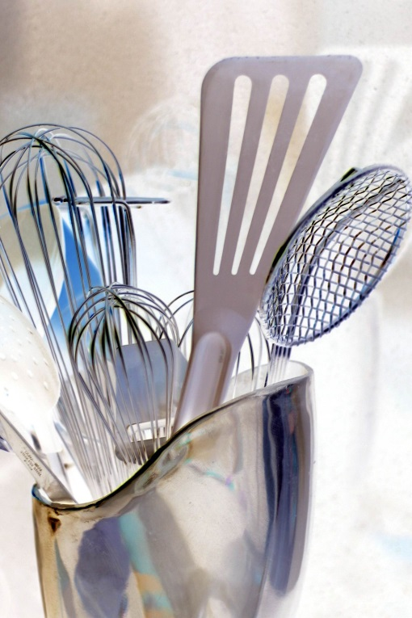
Measuring & Portioning Tools (cups, spoons, scoops, ladles)
Always use the "correct" measuring/portioning tools consistently.
Always use level measurements.

Knives
Sharpen regularly, usually daily.
Clean and sanitize after each use.
Hand wash only (never put through dish machine).
Hang knives with blades down.

Recipe Books
Don't think you can memorize. Always use the Recipe Book.
Measure precisely, don't approximate.

Lexans and Cambros
Used to store food
Always date, label and rotate when holding food
Always wash in dish area and store upside down

Scales
Clean and sanitize after use
Use consistently
Calibrate regularly using a separate weight
Always carry by base, never by platform

Sanitizing Solution & Spray Bottles
Make available throughout kitchen in prep and line areas
Use regularly on knives, utensils, counters, cutting boards and equipment

Kitchen Counters & Sinks
Clean and sanitize regularly
Use for food preparation only
Do not use chemicals

Can Opener
Clean after each use
Located on prep table

Slicer
Know proper settings for each product
Never leave unattended
Always keep hands away from blade
Keep clean, sanitize after every use

Pots, Pans and Holding Containers
Store in proper locations, always upside down
Send through dishwasher

Cutting Boards
Wash by hand only
Clean and sanitize after each use
When using, keep a damp towel underneath to keep from sliding

Utensils
Serving spoons - used for stirring or serving
Ladles - used for accurately portioning products
Tongs - long or short handles
Perforated or slotted spoons - used for stirring or serving
Whips - used to stir, whip or mix products

Cooling & Venting Products
After each evening shift there are hot products that must be properly cooled down and stored. Hot products must be covered and vented to prevent spoilage. Without proper venting, steam will continue to heat the product and it will take approximately twice as long to cool down. This causes the product to stay in the temperature danger zone (40-140 degrees F) too long and dramatically increases the chances of bacteria growth, contamination and spoilage.
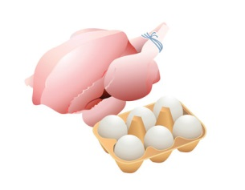
Containers that are covered with foil can be vented by carefully placing a hole about the size of your thumb in the foil on each side of the pan. BE SURE that no foil comes in contact with the product. This can cause product to become discolored and possibly spoil. Products that are stored with lids can be vented by placing the lid in a crooked fashion across the top of the container.
In addition to venting hot products, also make sure there is enough cool air surrounding each container. There should be at least 2 inches of space between each container to allow cold, circulating air to surround all sides of the container and cool the product down in the shortest amount of time possible.

Cooling Down Large Batches/Quantities of Product
Large quantities of certain products such as soups, baked beans and chili will take a long period of time to cool down. Because of the density of these products, they will remain in their danger zone too long, which increases the chances of spoilage, contamination and a decreased shelf life.
Additional steps must be taken to cool these products at a faster rate by using an ice bath. Fill a sink with ice and place the product in the largest and shallowest metal pan available. Put the pan on the ice for around 45 minutes while stirring occasionally. After the 45 minute period, remove from the ice, transfer to the proper storage container, then label, date and rotate and place in the walk-in.
Remember all products must be cooled down before they are placed in the walk-in!

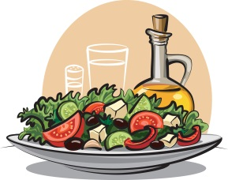
Controlling Waste & Spoilage
In order for our restaurant to be successful, we not only have to serve great food and deliver outstanding service but we also have to control our costs. Controlling costs is everyone's business and responsibility.
Here are some of the ways you can help to control costs and reduce waste:

Rotation | Improper rotation is a double-edged sword. When product don't get dated or aren't rotated properly they are more often subject to spoilage. Even worse, improper rotation increases the risk that we might serve something less than fresh, high quality food, which could mean a dissatisfied (or even sick) guest. Always label, date and rotate!
Portioning & Measuring | Always use the correct portioning and measuring tools (scoops, ladles, spoons, cups, scales). Don't over or under portion. Consistency is the name of the game!
Maximize Product Yields | Always get as much as possible from all produce, cans and jars. Be careful not to send good, usable product to the trash can.
Product Storage | Always follow proper cool down procedures. Not cooling down products properly before placing them in the walk-in can cause spoilage. Cover products properly to keep them fresh and good tasting.
Scraping | Always use a rubber scraper (spatula) on cans, jars, containers, etc., to get it ALL! This is a low margin business and those small amounts of product worth pennies, nickels and dimes add up to big dollars over time.

Conclusion
There is a lot of information contained in this manual! Believe it or not, however, there is even more information that is not.
We have given you the basics, as we view them, and how we would like them to be conducted.
We want you to use the service tips in the manual, along with your common sense, and above all, YOUR individuality, to help create an atmosphere that will encourage good times for our customers, and yourself. If this happens, you will be ensuring the success of not only the restaurant, but also yourself.
GOOD LUCK!!!

